Shuo Wang 001533020

**Program Structures & Algorithms**

**Fall 2021**

**Assignment No. 3**

* **Task (List down the tasks performed in the Assignment)**

Step 1:  
(a) Implement height-weighted Quick Union with Path Compression. For this, you will flesh out the class UF_HWQUPC. All you have to do is to fill in the sections marked with // TO BE IMPLEMENTED ... // ...END IMPLEMENTATION.

(b) Check that the unit tests for this class all work. You must show "green" test results in your submission (screenshot is OK).

Step 2:  
Using your implementation of UF_HWQUPC, develop a UF ("union-find") client that takes an integer value n from the command line to determine the number of "sites." Then generates random pairs of integers between 0 and n-1, calling connected() to determine if they are connected and union() if not. Loop until all sites are connected then print the number of connections generated. Package your program as a static method count() that takes n as the argument and returns the number of connections; and a main() that takes n from the command line, calls count() and prints the returned value. If you prefer, you can create a main program that doesn't require any input and runs the experiment for a fixed set of n values. Show evidence of your run(s).

Step 3:  
Determine the relationship between the number of objects (*n*) and the number of pairs (*m*) generated to accomplish this (i.e. to reduce the number of components from *n* to 1). Justify your conclusion in terms of your observations and what you think might be going on.

* **Relationship Conclusion: m = 3.4749n – 83.402**
* **Evidence to support the conclusion:**

1. **Output (Snapshot of Code output in the terminal)**

(In Step2_3.java) I tried the number of sites(n) from 1 to 500, and took the average of 100 trials for each n. Here is the result.

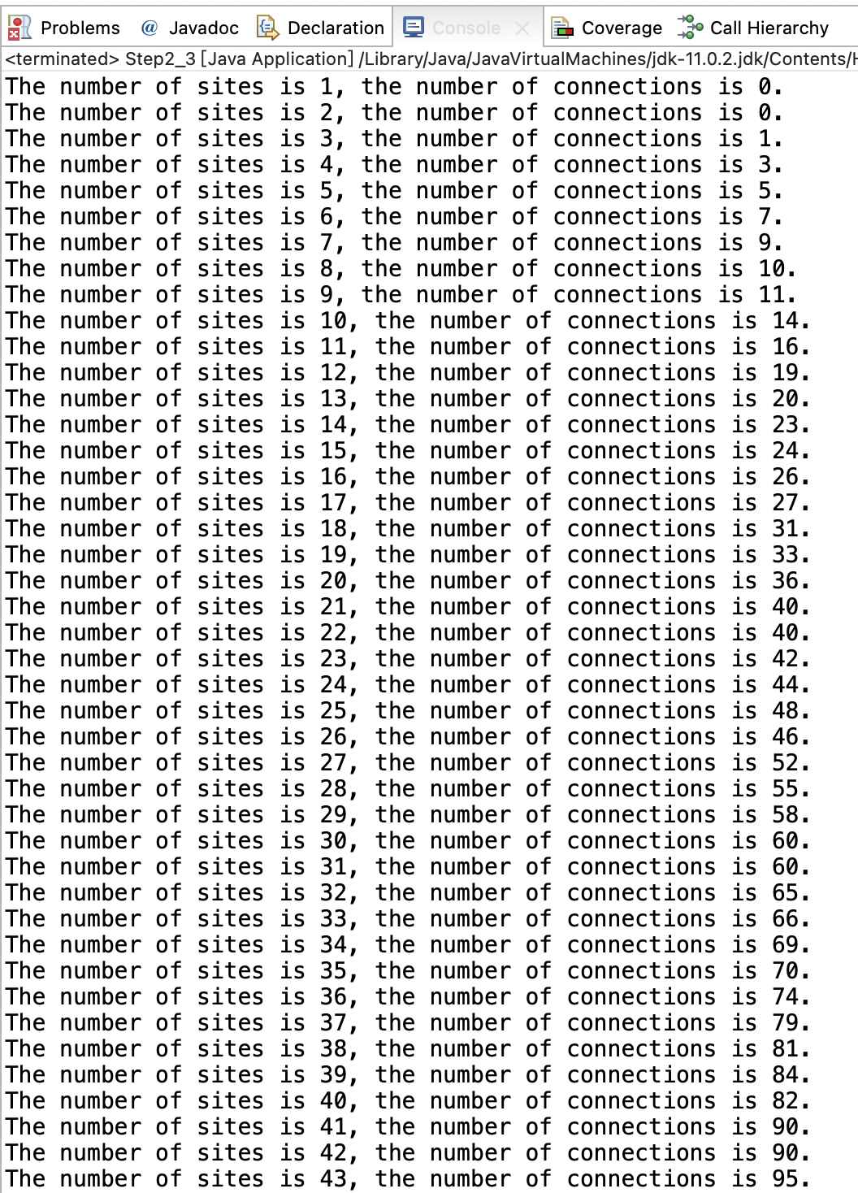

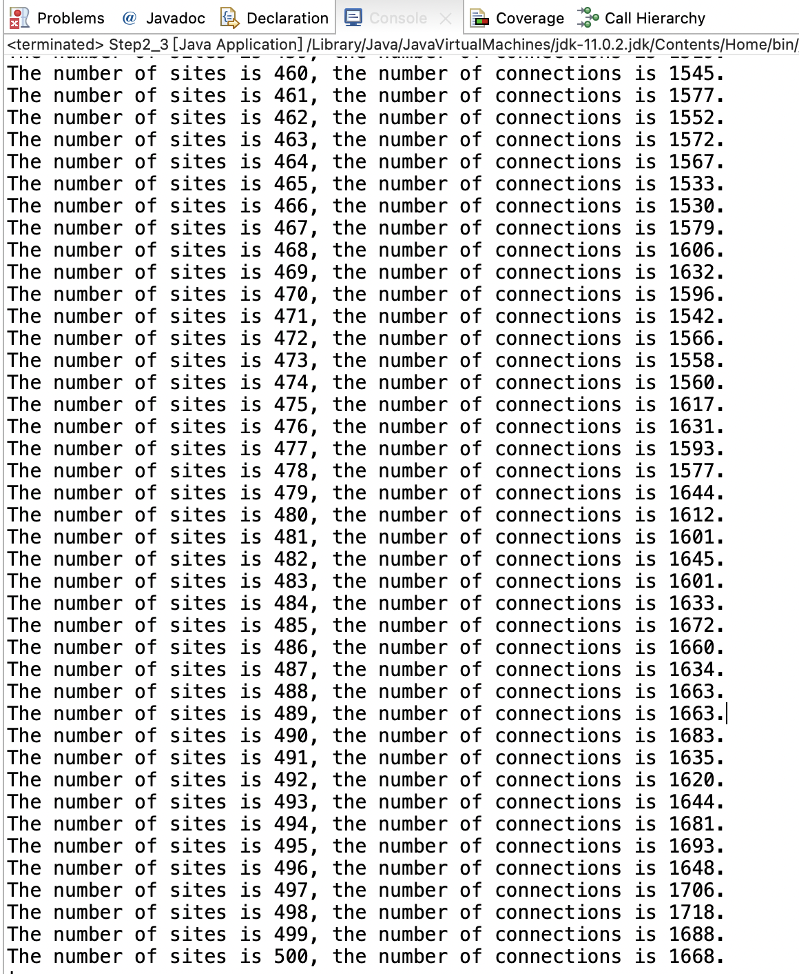

1. **Graphical Representation(Observations from experiments should be tabulated and analyzed by plotting graphs(usually in excel) to arrive on the relationship conclusion)**

By observing the experimental results, I found that the number of pairs (m) and  the number of objects (*n*) have a linear relationship. It is about m = 3.4749x – 83.402 .

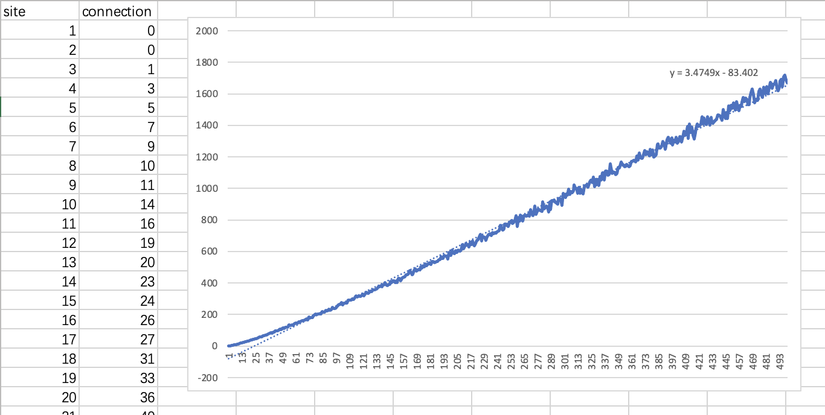

* **Unit tests result:(Snapshot of successful unit test run)**

